For Immediate Release

February 1, 2020. Cambridge, MA— The past, present, and possible future of the agency designed to act as “the world's environmental conscience.”
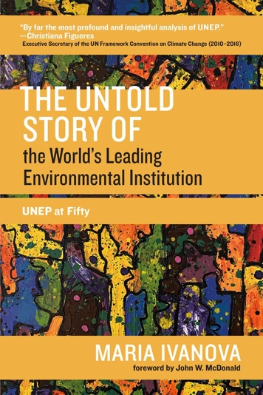
In Februrary, 2021, environmental ministers of the world convene at the virtual UN Environment Assembly and launch a year-long initiative to commemorate the 50th anniversary of the creation of the United Nations Environment Programme (UNEP).
Founded in 1972 as a nimble, fast, and flexible entity at the core of the UN system—a subsidiary body rather than a specialized agency – UNEP was intended to be the world's environmental conscience. It was to serve as the anchor institution that established norms and researched policy, leaving it to other organizations to carry out its recommendations. In The Untold Story of the World’s Leading Environmental Institution: UNEP at Fifty author Maria Ivanova offers a detailed account of UNEP's origin and history and a vision for its future. Ivanova counters the common criticism that UNEP was deficient by design, arguing that UNEP has in fact delivered on much (though not all) of its mandate.
Drawing on extensive interviews she conducted with UNEP's past and present Executive Directors, staff, and two former UN Secretaries-General, Ivanova provides rare insight into the organization's functioning. She shows that UNEP was able to resolve problems and launch important processes when it had financial and political support. Its failures and limitations came when the environment slipped as a priority, leadership faltered, and connectivity was challenged. UNEP's fiftieth anniversary, Ivanova argues, presents an opportunity for reinvention. She envisions a future UNEP that is the go-to institution for information on the state of the planet, a normative vision of global environmental governance, and support for domestic environmental agendas.
About the Author:

Maria Ivanova is Associate Professor of Global Governance and Director of the Center for Governance and Sustainability at the John W. McCormack Graduate School of Public Policy and Global Studies at the University of Massachusetts Boston. Ivanova is also a visiting scholar at the Center for Collective Intelligence at MIT.

The Untold Story of the World’s Leading Environmental Institution: UNEP at Fifty
From MIT Press’s One Planet series
$30.00 | £26.00 | paperback | ISBN: 978-0-262-54210-4
384 pp | 6 in x 9 in | 29 b&w illus.

Publication Date: February 23, 2020

Advance Praise

"Ivanova's book, by far the most profound and insightful analysis of UNEP, combines the author's research rigor with her heartfelt humanity.”
- Christiana Figueres, Executive Secretary, UN Framework Convention on Climate Change (2010–2016)

“Many promise but few deliver the kind of solid scholarship with policy pertinence as Ivanova has done for the ideational impact of UNEP, the undervalued 'anchor' in the battle to thwart the existential threat of climate change. Thoughtful, original, and hard-hitting.”
- Thomas G. Weiss, Presidential Professor of Political Science, CUNY Graduate Center

“A must-read for scholars, policymakers, activists, and industry—especially those tasked with leading humanity out of the current global environmental crisis.”
- Zakri Abdul Hamid, Former Science Advisor to the Prime Minister of Malaysia

"Ivanova's authoritative history of UNEP tells the story of how we have tried, succeeded, and failed to protect the environment. As multiple global crises trace their origins to nature's destruction, this is essential reading."
- Rachel Kyte, Dean of The Fletcher School, Tufts University

“Ivanova's in-depth, down-to-earth analysis of the evolution of UNEP offers lessons learned and forward-looking perspective and creates the cornerstone for enhancing global environmental governance. Genuinely captivating!"

- Ado Lõhmus, Permanent Representative of Estonia to UNEP, Vice-President of UNEA-5

